**Please be reminded that each individual teacher may require additional supplies**
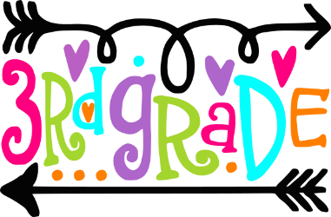
3rd Grade School Supplies 2019-2020

1 pack of (25+) pre-sharpened pencils
5- composition books
1 pair scissors
1 pack clear sheet protectors (25+)
1 1.5-inch binder with pockets (white)
1 pack index cards
4 pack Pentel Hi-Polymer erasers
1 durable pencil pouch (no boxes)
2 packs Crayola colored pencils (12 ct.)
Blue, black and red pens (2 each)
4 Elmer’s glue sticks (0.77g)
Sharpie Hi-lighters (4)
Headphones or earbuds in labeled pouch or container
Regular bookbag (no wheels)
*****Wish List Items*****
1 pack dry erase markers 2 reams white copy paper
Hand soap facial tissues
Lysol disinfecting spray Xerox multipurpose color paper

