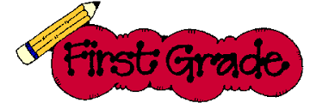

2019-2020 1st Grade Supply List
(Label everything with child’s name.)

1 backpack (no wheels please)
2 composition notebooks- Wide ruled (NOT primary journals)
4 packs of #2 pencils (24 count made in USA)
4 PLASTIC folders with pockets (NO PRONGS=2 red and 2 green)
1 plastic school box or large zipped case
4 white erasers (Magic Rub/Pentel preferred)
2 safety-tip (blunt) scissors
6 glue sticks
4 boxes of Crayola Crayons (16 or 24 count)
1 box of “FAT” markers (8 or 10 count)
Headphones or earbuds

WISH LIST:
2 reams of white copy paper
2 reams of color copy paper
2 packs of baby wipe refills
2 boxes of tissues
1 bottle of hand sanitizer
1 antibacterial bottle of soap

**Please place a few sharpened pencils, crayons, scissors, 2 glue sticks and 1 eraser in the box for daily use at school.** Keep an extra box for homework. Some items will need to be replenished during the school year. All unused supplies will be returned at the end of the school year.

